**Fantasy Football API – Authentication**

a brief overview on how to authenticate to gain access token. **1. Requirements**In order to be able to access the API, a vendor must obtain a valid API Key.  
  
  
**2. API End Points**Testing :   
<http://fantasy-football.code18.us/web/api>  
  
Production: TBA

**3. Access Token**Before we able to consume data from the API, we need to authenticate the user to get **Access Token**.  
The access token is an unique identifier valid for 1 day per user per API-Key.  
Upon expiration, the vendor must re-authenticate the user to get new **Access Token**.  
  
**4. Authentication Flow**  
  
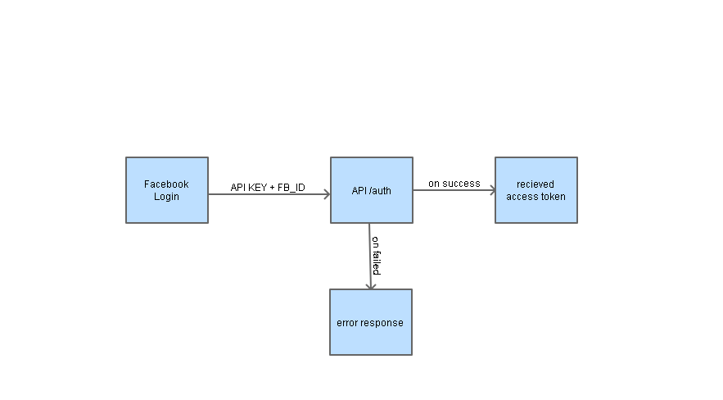

**5. API Specification**

**GET /auth**

|  |  |  |
| --- | --- | --- |
| **Parameters** | | |
| api_key | String | A valid API KEY |
| Fb_id | String / Number | A facebook id retrieved via Facebook Connect / Facebook Login. |
| **Response** | | |
| status | Int | Response Status. |
| access_token | String | An access token required for make an API Call. |
| **Status Code** | | |
| 1 | Success |  |
| 400 | User not found |  |
| 403 | Invalid API Key |  |
|  |  |  |

**6. Example**  
[http://fantasy-football.code18.us/web/api/auth?api_key=123456&fb_id=111111](http://fantasy-football.code18.us/web/auth?api_key=123456&fb_id=111111)  
  
Response :   
{"status":1,"access_token":"XmrX7sd2On2bDTVRSJPluegYlJSLLa9mg1Mbp6BmV03q8QgKMsGlMrc8yiLbP6byQBUdWayAUNXboNRPh-u8laYl6Eu4Iix2"}